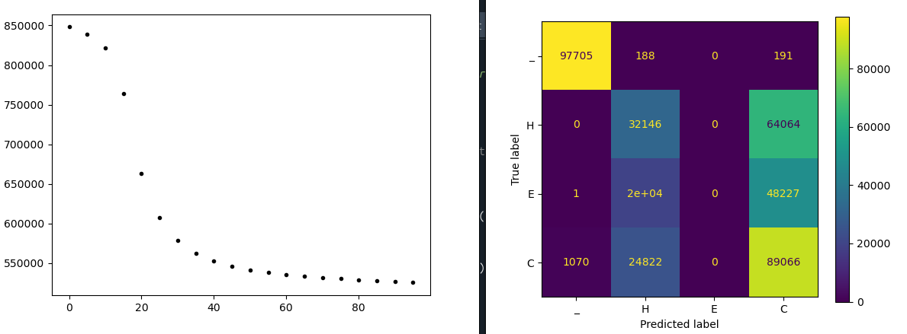
2025 06 26

with following features I got a “real” level of performance (low, of course)
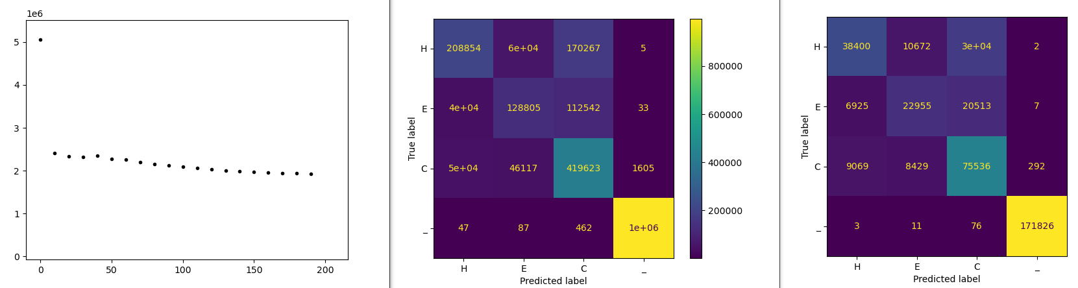

1. found bug that put an extra AA #20 (V) at end of all sequences. This was from the ‘\n’ at end of each record, and the .find() returning -1. solved by putting the space ‘_’ at end, so A is first and space is last.

2. switched to centering sequence in sequence space(using f'{clss[:maxLen]:^{maxLen}}' ) this puts equal space padding on each end.

Q: could this help as my padding puts zeros which are not spaces? Can test by setting maxlength to larger than max sequence size.

Just changing maxlength from 400 to 520, using a dataset with seq lengths 100 to 400, seems to make it WORSE! Is this real or just random? Is it the imbalance of the spaces?

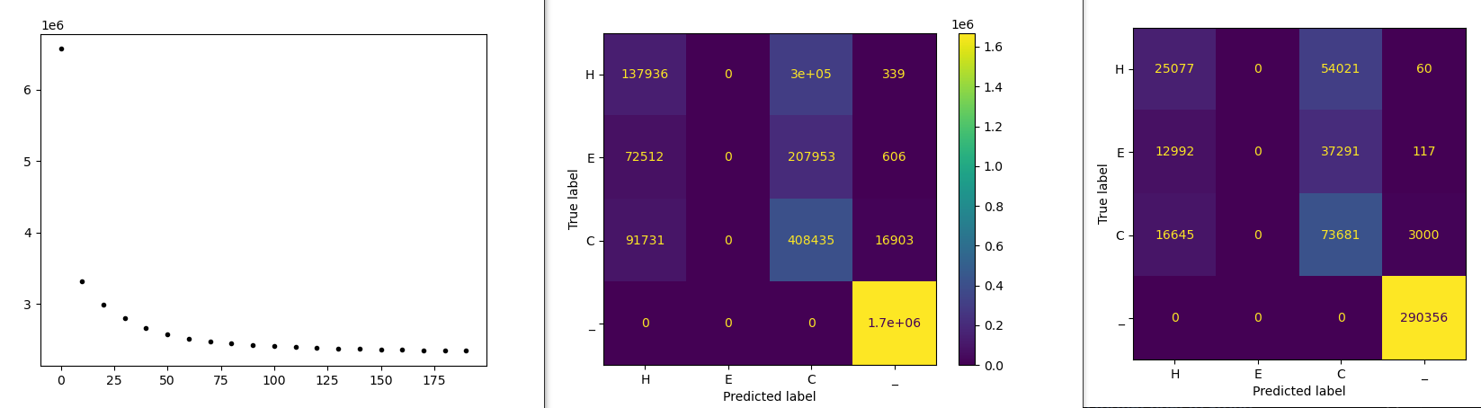

One experiment could be using sequences that completely fill the sequence frame. Say, use sequences from 200 to 400, but fit into

records of runs

run 1.

DATA SET
DATA ENTRIES CHANNELS LENGTH
training data 5589 21 400
training labels 5589 4 400
test data 987 21 400
test labels 987 4 400
number of batches: 1
size of batches: 5589

MODEL
MODULES PARAMETERS
layer1.weight 7161
layer1.bias 31
layer3.weight 6324
layer3.bias 4
TOTAL 13520

OPTIMIZATION
epoch batch loss
0 0 5023462.0
1 0 4915824.0
2 0 4796487.5
3 0 4648952.0
4 0 4459709.5
5 0 4225230.0
6 0 3964550.25
7 0 3722666.0
8 0 3539731.5
9 0 3417400.5
10 0 3334823.75
11 0 3274050.25
12 0 3225121.0
13 0 3183132.75
14 0 3145670.0
15 0 3111507.0
16 0 3079733.5
17 0 3050045.25
18 0 3022057.25
19 0 2995589.25

FINAL METRICS
training set performance
class recall precision
H 0.06341 0.3591
E 0.0 0.0
C 0.7101 0.3894
_ 0.9998 0.8217

test set performance
class recall precision
H 0.06409 0.3603
E 0.0 nan
C 0.7136 0.3905
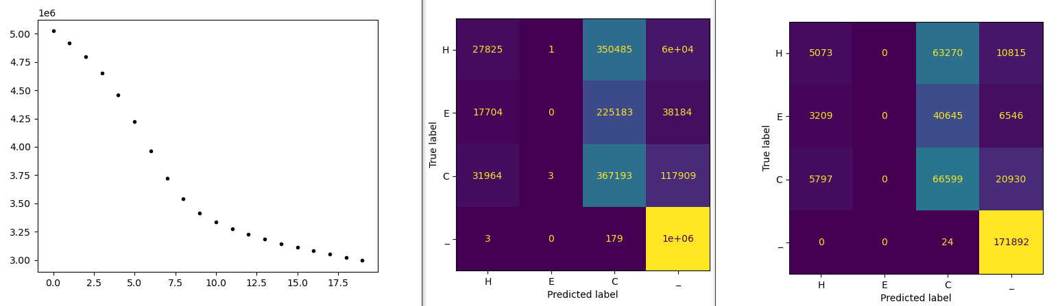
_ 0.9999 0.8178

